NAVIGATING BETWEEN HOME, HOST, AND GLOBAL: CONSEQUENCES OF MULTICULTURAL TEAM MEMBERS’ IDENTITY CONFIGURATIONS

Yih-Teen Lee, Aline D. Masuda, Xin Fu and B. Sebastian Reiche

Version March 2017

To be published in Academy of Management Discoveries

Copyright © 2015-2018, Yih-Teen Lee, Aline D. Masuda, Xin Fu and Sebastian Reiche. All rights reserved.

B. Sebastian Reiche, PhD
Professor
IESE Business School
Department of Managing People in Organizations
Ave. Pearson, 21
Barcelona 08034, Spain
Tel: +34 93 602 4491
E-mail: sreiche@iese.edu

navigating between Home, Host, and Global: Consequences of multicultural team members’ Identity Configurations

Abstract
As the world becomes more connected, individuals increasingly interact and collaborate with people of different cultural backgrounds, and hold multiple cultural identities. However, we know little about the effects of cultural identity configurations in the context of collaborative multicultural work. Therefore, we examine how identity configurations, derived from the joint effect of home, host, and global identities, relate to the cultural intelligence (CQ) and leadership perception of members of multicultural teams. Applying polynomial regression and response surface methods, we find that when global identity is low, individuals with balanced culture-specific identities (i.e., identifying equally strongly or weakly to both home and host cultures) demonstrate higher CQ and are more likely to be perceived as leader-like in multicultural teams compared to their counterparts with unbalanced culture-specific identities (i.e., identifying strongly either to home or host culture). However, when global identity is high, individuals of all identity configurations at the culture-specific level tend to show similar levels of outcomes. Based on our findings we propose a comprehensive global acculturation model, which expands Berry’s original typology of acculturation orientations, taking into account both culture-specific and global identities. We also provide insights for further development both of theory and of managerial practice.

Keywords: identity configurations, home identity, host identity, global identity, cultural intelligence, leadership perception, acculturation model.

I do not want my house to be walled in on all sides and my windows to be stuffed. I want the cultures of all the lands to be blown about my house as freely as possible. But I refuse to be blown off my feet by any.
Mahatma Gandhi (1869 - 1948)
As the peoples of the world become ever more interconnected, business activities regularly reach across cultural boundaries. This has led to an increase in the compositional diversity of collaborative work as organizational members jointly operate in a multicultural context, sometimes even within one member’s country of origin, and interact more frequently with people from different cultural backgrounds (Hinds, Liu, & Lyon, 2011; Lisak & Erez, 2015). Further, as complexity increases in global organizations, in which stakeholders are highly interdependent and change occurs in different directions and at varying levels of speed (Reiche, Bird, Mendenhall, & Osland, in press), collaborative work also becomes more self-directing (Cheng, Chua, Morris, & Lee, 2012). Self-managed multicultural teams provide a particularly important context for exploring such collaborative work for two reasons. First, members are simultaneously exposed to multiple cultures, including their original cultures (home culture), the culture in which the team interactions take place (host culture), and the diversity of cultures present within the team. Second, without shared cultural practices and formally assigned leadership to provide structure, team members are also more likely to be exposed to multiple sources of identification (Stahl, Maznevski, Voigt, & Jonsen, 2010).
Scholars have emphasized that such exposure may reshape and extend individuals’ identities and sense of self (Arnett, 2002; Giddens, 1991; Hermans & Dimaggio, 2007). Any exposure to culturally pluralistic settings also triggers a process of acculturation, not only for immigrants (Crisp & Turner, 2011; Molinsky, 2010). As a result, individuals may hold multiple cultural identities (Chao & Moon, 2005; Ramarajan, 2014; Stryker & Burke, 2000). We expect that multicultural team members may simultaneously hold identities connected to their cultural origin (i.e., home identity), to the specific host culture of the country in which they are currently based (i.e., host identity), and to an overarching global community (i.e., global identity; Erez & Gati, 2004), each with potentially different degrees of identification. Whereas home and host identities function at the culture-specific level, the global identity operates at the culture-general level. Together, these three identities suggest several possible identity configurations, raising the questions of (1) whether it matters how self-managed multicultural team members define themselves culturally for important work outcomes, and if so, (2) how the work outcomes of distinct identity configurations differ. Serving a self-regulatory function, identities influence people in directing attention, determining attitudes, and orienting behaviors (Ashforth & Mael, 1989; Hogg & Terry, 2000; Markus & Wurf, 1987). Given such far-reaching effects, it is critical to understand the consequences of different cultural identity configurations for self-managed multicultural teams.
To date, we know very little about how these identities—seemingly in tension (e.g., home vs. host; culture-specific vs. global) and with conflicting identity demands (Kreiner, Hollensbe, & Sheep, 2006)—affect work-related outcomes in multicultural teamwork. Despite earlier forceful calls from Leung, Bhagat, Buchan, Erez, and Gibson (2005) and Gelfand, Erez, and Aycan (2007) for more research efforts to understand the functioning of different identities in the fields of international business and cross-cultural organizational behavior, the progress appears far from satisfactory (Adams & van de Vijver, 2015). Our current knowledge about how multiple identities jointly influence individuals in cross-cultural settings is mainly based on the frameworks derived from acculturation (Berry, 1980) and biculturalism research (Brannen & Thomas, 2010; LaFromboise, Coleman, & Gerton, 1993). The commonly shared view largely favors an integration mode of dual culture-specific identities (i.e., maintaining strong identification to both home and host cultures, Berry, 1997). However, this fails to capture the complexity of multiple cultural identities of non-migrant professionals. For example, multicultural team members, especially in self-managed settings, generally enjoy more freedom in crafting their cultural identities than do immigrants (Adams & van de Vijver, 2015; Ailon-Souday & Kunda, 2003). Not identifying with any one culture may in fact be beneficial for multicultural work (Bennett, 1993; Fitzsimmons, Lee, & Brannen, 2013; Lee, 2010) yet this has neither been studied nor understood sufficiently. For example, Bennett (1993) points to a constructive form of marginality, which enables individuals to shift cultural frames with ease. Similarly, Fitzsimmons et al. (2013) propose that cultural marginals may excel as global leaders because the unique process of their identity construction allows them to better cope with diversity, complexity, and uncertainty. There is a pressing need to develop knowledge about the configuration and effect of multiple identities in self-managed multicultural teams.
Further, because the global and the local are closely interconnected nowadays, it is necessary to study the effect of identities jointly at both culture-specific and global levels. So far, the few studies that have explicitly studied the identities of individuals involved in multicultural work have focused either only on the culture-specific level (i.e., home and host identities; e.g., Lee, 2010) or only on the global level (i.e., global identity; e.g., Lisak & Erez, 2015). These studies hence do not offer a full account of how these identities interact within and across culture-specific and global levels in affecting relevant work outcomes in a multicultural environment. As a result, research remains relatively silent on a number of identity-related questions in self-managed multicultural teams: When is attachment to one’s home culture beneficial? Should one strive to identify with the local culture when self-managed teamwork occurs in a different host culture? What happens if one does not identify strongly with any culture (thus feeling “culturally homeless”)? Is it sufficient to simply develop a global identity and let go of culture-specific identities? How do these identities interact and what are the consequences of such identity configurations for self-managed multicultural teams? Our study intends to address these pertinent questions, and eventually expand Berry’s acculturation framework by taking into account the role of global identity.
Effects of multiple cultural identities in MuLticultural teams
To effectively perform work in self-managed multicultural teams, which by definition transcend cultural boundaries and lack formally assigned leadership (Kirkman & Shapiro, 1997), team members need to be both cross-culturally proficient and able to be seen as contributing leadership to the team (Shokef & Erez, 2008; Zander, Mockaitis, & Butler, 2012). We therefore conceptualize CQ and leadership perception as our primary work outcomes. CQ refers to a person’s capability to effectively function in culturally diverse environments and involves four interrelated foundational components (Ang & Van Dyne, 2008; Earley & Ang, 2003). The metacognitive dimension constitutes the mental processes used to gain and make sense of cultural knowledge, while the cognitive dimension concerns the knowledge about the norms, practices and customs of different cultures obtained through education and personal experience. The motivational dimension enables individuals to direct their attention and energy toward cross-cultural interaction, whereas the behavioral dimension reflects the enactment and demonstration of culturally appropriate behaviors by individuals according to the norms and requirements of specific cultural situations. Previous research has shown that multicultural team members with high levels of CQ better integrate into, and adjust to, their teams (Shokef & Erez, 2008).
Leadership perception refers to the likelihood that other members of a collective will perceive a given person as a leader (Lord & Hall, 2005). Being perceived as more leader-like facilitates others granting leadership to a focal individual (DeRue & Ashford, 2010). This makes it easier for that person to influence people, coordinate tasks, and accomplish a mission (Yukl, 2006), especially in team contexts where members have little in common due to the diversity of cultural backgrounds and encounter both high degrees of autonomy and few predetermined rules and structures to follow (Cheng et al., 2012).
Cultural Identities, Cultural Intelligence and Leadership Perception
Whereas identity is the subjective concept of oneself as a person, encompassing the whole set of knowledge, meanings, and experiences that are self-defining (Ramarajan, 2014; Stets & Burke, 2000), cultural identity can be defined as “a sense of solidarity with the ideals of a given cultural group and to the attitudes, beliefs, and behaviors manifested toward one’s own (and other) cultural groups” (Schwartz, Montgomery, & Briones, 2006: 5). As “the representation of what individuals think, feel, or believe about themselves” (Markus & Wurf, 1987: 300), identities are the most powerful regulators of human cognition, affect, and behavior. Located at the level of subjective psychological experiences, identities provide a lens through which individuals perceive and make sense of the world and enable them to connect meaning and actions (Ashforth, Harrison, & Corley, 2008; Ramarajan, 2014). When individuals identify strongly with a given culture, they see things from that cultural group’s perspective, feel being at one with the cultural group, and act according to the norms of the cultural group (Stets & Burke, 2000).
As the effect of specific identities may help or hinder individuals’ competences in performing tasks (e.g., Shih, Pittinsky, & Ambady, 1999), we expect a link between individuals’ cultural identities and CQ. While previous research has examined various predictors of CQ (e.g., Engle & Nehrt, 2012; Sahin, Gurbuz, & Köksal, 2014), we know little about how individuals’ cultural identities relate to their CQ. The broader identity literature, however, has elaborated upon the mental, affective, and behavioral foundations of identity. Identity addresses the cognitive needs of individuals to understand “who I am” and is commonly defined as an individual’s perceived affinity with, and oneness toward, some human aggregate (Pratt, 1998). Indeed, an important cognitive process in identity theory is de-personalization, which refers to viewing the self as an embodiment of the in-group prototype (Hogg, 2001; Stets & Burke, 2000). As such, dual identities make cultural comparisons more salient and hence lead to a deeper understanding of cultural similarities and differences (i.e., cognitive CQ). At the same time, given how central identities are to individuals’ self-concept (Stets & Burke, 2000) we would also expect their cultural identities to influence the way individuals obtain and make sense of cultural knowledge and, in doing so, relate to their metacognitive CQ. In fact, research has shown that one’s identity pattern may facilitate the processing of certain information so that specific cultural knowledge may be cognitively accessible (Hong, Benet-Martínez, Chiu, & Morris, 2003; Verkuyten & Pouliasi, 2006). Additionally, empirical studies on biculturalism have shown that individuals with a dual identity develop a heightened level of cognitive/integrative complexity (Benet-Martínez, Lee, & Leu, 2006; Tadmor, Tetlock, & Peng, 2009). The cognitive complexity may be necessary for an individual to acquire a higher sense of cultural awareness and ability to plan ahead before having a cultural encounter, both of which are aspects of metacognitive CQ.
Scholars have long established the link between identity and motivation (Haslam, Powell, & Turner, 2000; Markus & Wurf, 1987). Specifically, identities include not only content about “who I am” but also the motivation and readiness to act in ways that are congruent with one’s identity and self-categorization (Ellemers, De Gilder, & Haslam, 2004). The strength of one’s cultural identities will undoubtedly affect the degree of intrinsic motivation to interact with people of different cultures.
Further, individuals’ identities may affect their behavioral adaptation, as identities determine which group norms individuals consider as self-defining and are hence willing to conform to (Haslam et al., 2000; March & Olsen, 2005). Molinsky (2013) suggests that the extent to which individuals are able to engage in cross-cultural adaptation is related to their identities. Specifically, individuals’ identities influence whether they will encounter authenticity (i.e., this is not me) and resentment (i.e., this is imposed on me by others) challenges when adapting their behaviors required by specific cultural situations. Similarly, individuals with more diverse identities, including cultural identities, should also be able to adjust better to new environments because they can draw on and enact different dimensions of these identities according to the situational demands (Beyer & Hannah, 2002).
We also believe that individuals’ cultural identities relate to the extent to which they will be perceived as leader-like in self-managed multicultural teams. Evidence suggests a close connection between one’s concept of self, one’s social identity, and perceptions of leadership (Lord & Hall, 2005; van Knippenberg & Hogg, 2003). Extant literature has generally demonstrated that high levels of shared identity among employees results in more positive leader perceptions (Martin & Epitropaki, 2001). Using a social identity and social categorization lens Hogg (2001) further argues that individuals are more likely to judge others’ influence in a group based on their perceptions of how prototypical each is of the group. This prototypicality has been shown to affect followers’ perceptions of leaders (e.g., Platow, van Knippenberg, Haslam, van Knippenberg, & Spears, 2006). Research has also conceptualized leadership emergence as a socially constructed process in which individuals grant a particular leadership identity (DeRue & Ashford, 2010). We would therefore expect that one’s own cultural identities affect whether the focal individual will be perceived by multicultural team members as a leader.
To date, the relationship between multicultural team members’ multiple cultural identities (specifically, home, host, and global identities) and their CQ and leadership perception remains largely unknown. The value of identifying strongly with one’s cultural origin has been widely discussed. Although globalization enriches people’s lives, it also generates uncertainty for people facing unfamiliar events. Anchoring oneself to the home culture helps individuals find security, safety, and comfort in a local niche (Fu, Morris, & Hong, 2015). For instance, Ailon-Souday and Kunda (2003) found that organizational members actively mobilize home identity as a symbolic resource to confront challenges triggered by globalization. However, strong identification with one’s home culture may also narrow the cultural mindset and create an ethnocentric attitude that prevents individuals from engaging in intercultural exchanges (Chen et al., 2016). For example, Tong, Hui, Kwan and Peng (2011) found that when individuals strongly identified with their home culture, they tended to react to cross-border transactions with a nationalistic mindset. Similarly, holding an identity toward the host culture fosters mutual liking and reduces out-group biases toward the host culture (Ellemers, Spears, & Doosje, 2002), and facilitates individuals’ integration into the host culture with less sociocultural adjustment difficulties (Berry, 1980; 1997; Ward & Kennedy, 1994). However, identifying strongly with the host culture at all cost may not be effective for developing CQ or for being perceived as a leader in a work context that transcends diverse cultural boundaries.
What We Know and Don’t Know About Identity Configurations in Multicultural Teams
Given that home and host identities often operate in tandem rather than in isolation, while also evoking conflicting demands, we contend that the effects of these two identities need to be examined jointly, similar to acculturation theory (Berry, 1980; 1997). According to the acculturation framework, there are four distinct types of acculturation orientations based on the degree to which one identifies with the ‘home culture’ and the ‘host culture’. These orientations include integration (identifying with both home and host cultures), assimilation (identifying with host but not home culture), separation (identifying with home but not host culture), and marginalization (identifying with neither home nor host culture). The dominant view derived from acculturation and biculturalism theory advocates the superiority of an “integration” orientation to other identity configurations (Berry, 1997; Nguyen & Benet-Martinez, 2013; Tadmor et al., 2009; Ward & Kennedy, 1994). Individuals identifying strongly with both home and host cultures seem to suffer less acculturation stress and adjust better to new cultural environments.
However, for several reasons this view needs further refinement. First, these findings are based on immigration research, especially with migrants from developing countries moving to Western countries, and may therefore not be fully applicable to members of self-managed multicultural teams. Scholars have started differentiating between immigration-based and globalization-based acculturation (Chen, Benet-Martínez, & Bond, 2008), suggesting that individuals may enjoy varying degrees of freedom in incorporating different cultural elements. In comparison to migrants, non-migrant professionals generally have more choice regarding their own acculturation due to their exposure to relatively more cultures and their superior socioeconomic status (Ailon-Souday & Kunda, 2003). In other words, the latter can be more selective in the degree to which they identify with or adjust to a particular host culture (Adams & van de Vijver, 2015), even if work needs to be completed in the host context and in the presence of host-national co-workers. In fact, non-migrant professionals may sometimes even consciously distance themselves from the home and/or host culture (Mao & Shen, 2015).
Second, emerging evidence suggests that not identifying strongly with any culture, or exhibiting the “marginalization” identity configuration according to Berry (1997), may yield higher performance outcomes than identifying strongly only with the home or host culture. For instance, Lee (2010) found that such individuals demonstrated higher intercultural effectiveness than their counterparts with unbalanced identification to home or host cultures. Rather by accident, for it was not part of their original research question, Ward and Kennedy (1994) and Tadmor et al. (2009) found similar advantages of not identifying with any one culture. In fact, the concept of balance has started to appear in recent works on acculturation (Harush, Lisak, & Erez, 2016; Stuart & Ward, 2011; Ward, 2013) and expatriate identities (Lee, 2010; Kohonen, 2008). This research suggests that holding a balanced identity pattern (i.e., holding a balanced identification to home and host cultures vs. an unbalanced identity toward only one culture) is similar to handling paradoxical identity tensions without resorting to simple compromise (Lewis, 2000). Specifically, it increases social identity complexity (Roccas & Brewer, 2002), which in turn reduces out-group biases (Crisp, 2010). Such an identity pattern also enhances self-multiplicity, which may free individuals from one specific cultural frame and allow them to adapt to different cultural contexts (Dimaggio, Hermans, & Lysaker, 2010). In sum, while the dominant theoretical perspective points to the superiority of integration over other identity configurations, insights from the aforementioned studies inspired us to examine which configurations of home and host culture identities enjoy superior outcomes in the context of self-managed multicultural teams.
Irrespective of their culture-of-origin, individuals are commonly thought to maintain a three-tiered hierarchy of identities that involve their individual self, followed by their relational self and, finally, their collective self (Gaertner et al., 2012). However, even at the level of the collective self, which forms the focus of our study, research has shown marked differences in the relative weight that various social identities may have. For example, social identity scholars have highlighted how members of different social groups can be induced to view themselves as a single, more inclusive superordinate group rather than as two separate groups, thereby reducing intergroup bias (Dovidio, Gaertner, & Saguy, 2009). One salient superordinate identity in the context of multicultural work is global identity, which is defined as a sense of belongingness to mankind in a global community that transcends national boundaries and cultural divisions (Arnett, 2002; Erez & Gati, 2004). Individuals with a strong global identity generally defy simplistic and conventional categorizations of culture (Kim, 2009). In general, global identity “widens the range of inclusiveness, allowing multicultural team members to see beyond their national differences and to perceive culturally diverse team members as belonging to one’s in-group” (Erez, Lisak, Harush, Glikson, Nouri, & Shokef, 2013: 336). Global identity, along with culture-specific identities, should therefore also be associated with multicultural team members’ CQ and leadership perception (Lisak & Erez, 2015).
Given the “intimate interconnection between the global and the local” (Hermans & Dimaggio, 2007: 31), we contend that global identity should be studied together with identities at the culture-specific level (i.e., home and host identities), accounting for possible interaction among them. This endeavor may provide a more comprehensive model of acculturation that would expand Berry’s framework beyond culture-specific identities to explicitly include global identity, which is of critical relevance in the global workplace. Our work will also advance the initial conceptual effort of Erez and her colleagues (Shokef & Erez, 2006; Harush et al., 2016), which has introduced global identity in the acculturation model but does not capture the full complexity of the phenomenon by only focusing on one single culture-specific identity (i.e., local identity in their terms).
In summary, recent research has started to point to inconsistent empirical evidence and insufficient theorizing regarding how cultural identity configurations relate to CQ and leadership perception in multicultural collaborative work. We therefore will examine how individuals’ home, host, and global identities interact to predict these relevant outcomes in the particular context of self-managed multicultural teams.
method

Sample and Procedure
We collected data from experienced professionals involved in self-managed multicultural teamwork in the context of MBA and international master programs at two European business schools. In total, 196 participants representing 35 different nationalities participated in the study, of which 137 were enrolled in an MBA program and 59 in an international master program. Both programs are highly international and ninety-five percent of the participants were foreigners. Hence, the country in which the programs took place served as the host culture for them. On average, participants had lived in 2.27 countries and had four years of work experience prior to enrolment. The participants collaborated in multicultural teams during the program, as they were asked to work as real professional teams that were composed of members of diverse cultural backgrounds (all members came from different cultures) and that required regular and frequent interactions to deliver collective results (i.e., producing a video on leadership challenges based on real-life incidents and enacted by the team members). The participants were assigned to 30 teams that remained stable during the time of the study. Further, there were no formally assigned leaders so they functioned as self-managed teams. Among the participants, 29% were female and 71% male.
We collected both self-reporting and peer-assessment data through an on-line platform at two different times. Whereas participants self-reported their cultural identities at the beginning of the program (i.e., Time 1), we obtained the information about their CQ and leadership perception through team member assessments three months later when teams had accomplished an important team project (i.e., Time 2). After accounting for missing data and excluding participants whose home and host cultures were identical, the final sample size involved 172 participants in 30 teams.

Measures
Home, host, and global identity. We used the global identity scale developed by Erez and Shokef (Erez & Gati, 2004; Shokef & Erez, 2008; further validated by Lisak & Erez, 2015) to measure global identity (GI). The same scale is adapted to measure home identity (SI) and host identity (HI) by changing the referent culture of the items to home and host culture, consistent with Erez et al. (2013). Sample items are “I define myself based on my nationality” (home identity), “I define myself based on the country I currently live in” (host identity), and “I would define myself as a citizen of the global world” (global identity). We used self-reporting data to measure these cultural identities at Time 1. The Cronbach’s alphas for home, host, and global identity are .87, .86, and .86 respectively.
Cultural intelligence (CQ). We measured CQ at Time 2, using the nine-item cultural intelligence scale (i.e., the Mini-CQS) developed by Ang & Van Dyne (2008). Team members were asked to assess all other team members on their CQ in reference to the experience of accomplishing the project. We used the average score of all members’ assessment for each individual. Sample items are “s/he enjoys interacting with people from different cultures” and “s/he changes his/her verbal behavior (e.g., accent, tone) when a cross-cultural interaction requires it” (Cronbach’s α = .94). Because we aggregated the assessment of team members for each individual, we checked the interrater agreement with r_{wg(5)} (James, Demaree, & Wolf, 1993). The mean of r_{wg(5)} for CQ is .91, with the assumption of a slightly skewed distribution, which indicates a high level of agreement among raters (LeBreton & Senter, 2008).
Leadership perception. We used the General leadership impression (GLI) scale of Cronshaw and Lord (1987) to measure leadership perceptions at Time 2. Team members provided their assessment of leadership perception of other team member, with five questions on a 7-point Likert scale. A sample item is “How likely would you choose this individual as a formal leader?” (Cronbach’s α = .98). The mean of r_{wg(5)} is .82 with the assumption of a slightly skewed distribution.
Control variables. In addition to gender and age, we controlled for the number of countries that participants had stayed in for more than six months and the number of languages spoken as these variables could be related to CQ. Because the participants in our study are individuals nested in teams and programs, we created 29 team dummies and a program dummy to account for the fixed effect of team membership.
Analytical Strategy
To investigate the effect of multiple cultural identities and their possible interaction simultaneously, we applied polynomial regression, together with the response surface method (Edwards & Parry, 1993; Edwards, 1994) and the moderated polynomial regression method (Edwards, personal website). This method can be considered a person-centered approach, which allows us to study the effects of the three cultural identities simultaneously and holistically (instead of a variable-centered approach which focuses on the statistical significance of the variables of interest one at a time; Bergman, 1998), and depict the relationship between specific configurations and outcomes resulting from analyses of the shape of response surfaces. In fact, each corner of the response surfaces represents a specific configuration reflecting the combination of our three predictors (i.e., home, host, and global identities). Moreover, by examining the shape of the surface with the help of testing the slope and curvature of special lines of interests on the surface (Edwards & Parry, 1993), and by comparing the level of each dependent variable at different corners of the response surfaces, we are able to discover how home, host, and global identities jointly influence key outcomes of global work in a precise way.
We scale-centered the three identity-related variables (i.e., SI, HI, and GI) before conducting the regression analyses to avoid the potential problem of collinearity and facilitate interpretation of the results with the response surface method (Edwards & Parry, 1993). We conducted hierarchical regressions in three steps: first-order SI and HI were introduced in the first step, before entering the quadratic terms (i.e., SI², SI*HI, HI²) in the second step. The interaction between SI and HI captures the original configurations of Berry’s two-by-two (2x2) acculturation model. In the third step, we introduced the main effect of GI and its interaction with the previous terms relating to cultural identities (i.e., GI, GI*SI, GI*HI, GI*SI², GI*SI*HI, GI*HI²) into the regression equation. The additional interaction of GI with the previous set of variables allows us to investigate possible variations of Berry’s model when global identity is high versus low, hence expanding the original acculturation model to a two-by-two-by-two (2x2x2) space.
Because our data is hierarchically nested in teams, to account for the team-level fixed effects (i.e., the unobserved team-invariant constant effects common to those members nested in a team), we introduced 29 (team n = 30) dummy or indicator variables in the polynomial regression (Antonakis, Bendahan, Jacquart, & Lalive, 2010; Preacher, Zyphur, & Zhang, 2010). The program dummy is also introduced in the regressions. We have also conducted multilevel analyses with team-level random effects, and obtained very similar results (available upon request). However, because our research interest is on within-team variations, to match our level of theory with that of our measurement and analytical methods (Kozlowski & Klein, 2000), we report the results with team fixed effects below.
Results
Table 1 reports the means, standard deviations, and correlations of our variables. We first conducted a series of confirmatory factor analyses (CFA) to check for measurement validity. The results indicate that all the items fall appropriately into their conceptual constructs and that the measurement model is valid, with Chi-square (349) = 588.75, CFI = .95, RMSEA = .06. In order to test the discriminant validity of our five-factor model, we compared the goodness of fit of our model with seven other models, which are most likely grounded in the data. As illustrated in Table 2, our five-factor model fits the data the best. Further, in our five-factor model, all items have significant loadings on their respective factors; therefore, we can examine these variables as five distinct constructs in the following analyses.
-------------------------------------

Insert Table 1 & 2 about here
-------------------------------------
The results of our hierarchical polynomial regressions with CQ and leadership perception as dependent variables are reported in Table 3. As observed, the two-way interaction (i.e., SI*HI) and the three-way interaction terms (i.e., GI*SI*HI) are all significant. These results are consistent with our speculation that home, host, and global identities will interact in predicting our outcomes, and that they need to be studied jointly with proper methods to capture the complex relationship among them. We plotted the response surfaces of these relationships for high and low GI groups (Aiken & West, 1991), and tested the slope and curvature of each surface (Edwards, 1994), as reported in Table 4.
-------------------------------------

Insert Table 3 & 4 about here
-------------------------------------
The relationship between the interaction of multiple cultural identities and CQ is shown in Figure 1. For individuals with low global identity (ref. Figure 1a), those with high-home/high-host identities (Point A) and low-home/low-host identities (Point C) demonstrate higher levels of CQ than those with high-home/low-host identities (Point B) and low-home/high-host identities (Point D). This pattern is confirmed by the tests of slope and curvatures along lines of interests (see Table 4). Along the SI = - HI line, the significant negative curvature (-.22, p < .01) shows that the two ends of the surface along this line (i.e., Points B and D, representing individuals with unbalanced identities) are significantly lower than the ridge (i.e., the line linking Points A and C, representing individuals with balanced identities). Moreover, along the SI = HI line, both the slope and curvature are not significantly different from zero, indicating that the level of CQ is not significantly different between individuals with high-home/high-host and low-home/low-host identities.
-------------------------------------

Insert Figure 1 about here
-------------------------------------
To obtain an even more precise picture in our discovery, we conducted direct comparison tests between different pairs of points on the response surfaces. As shown in Table 5, for individuals with low global identity, high-home/high-host identities is associated with significantly higher CQ than high-home/low-host identities and low-home/high-host identities (χ²(1) = 4.00, p < .05; χ²(1) = 12.96, p < .01, respectively). Similarly, low-home/low-host identities is also related to higher CQ than the unbalanced identities (χ²(1) = 14.30, p < .01; χ²(1) = 7.98, p < .01, respectively). In addition, there is no significant difference between high-home/high-host identities and low-home/low-host identities (χ²(1) = .02, n.s.). These results indicate that, when global identity is low, balanced culture-specific identities are more strongly associated with CQ.
-------------------------------------

Insert Table 5 about here
-------------------------------------
For individuals with high global identity, the surface tends to be flat (ref. Figure 1b), indicating that there is no significant difference in CQ for individuals with different combinations of high/low home and host identities. The tests of curvatures along lines of interest (see Table 4) show that the curvature of the surface is not significantly different from zero on the SI = - HI line (-.01, n.s.), indicating that the surface is not significantly bent downward at Points B and D. The direct comparison in Table 5 demonstrates that this is the case, as there is no longer a significant difference among different corners of the surface. As shown in Panel 2 of Table 5, a high global identity significantly increased cultural intelligence for those with unbalanced identities (χ²(1) = 7.83, p < .01 for Point B; χ²(1) = 11.27, p < .01 for Point D). These results, together with the result for the low global identity group, suggest that global identity compensates for the disadvantageous effect of holding unbalanced culture-specific identities on CQ.
Next, we investigated the relationship between the interaction of multiple cultural identities and leadership perception, as reported in Table 3 and Figure 2. Specifically, Figure 2a shows that for those of low global identity, individuals with balanced culture-specific identities are more likely to be perceived as leaders. As shown in Table 4, the flat slope along the SI = HI line (-.10, n.s.) suggests that the level of leadership perception is equal for those with high-home/high-host and low-home/low-host identities (see also the comparison of Point A with C in Table 5). At the same time, those with unbalanced culture-specific identities are much less likely to be perceived as leaders (supported by the negative curvature along the SI = - HI line, -.47, p < .01). Table 5 reports additional support for such findings: for individuals with low global identity, high-home/high-host identities are associated with significantly higher leadership perception compared to low-home/high-host identities (χ²(1) = 7.07, p < .01) but not to high-home/low-host identities (χ²(1) = 1.22, n.s.). On the other hand, low-home/low-host identities are related to higher leadership perception compared to both patterns of unbalanced culture-specific identities (χ²(1) = 4.58, p < .05; χ²(1) = 9.13, p < .01, respectively).
For those with high global identity, the surface looks much flatter, indicating little difference between those with balanced and unbalanced identities (Figure 2b). As shown in Table 4, the curvature along the SI = - HI line is no longer significant (-.07, n.s.), suggesting that the two corners along the SI = - HI line (i.e., Points B and D) are not significantly bent downwards. The Chi-square results of the direct comparison in Panel 1 of Table 5 also show no significant difference among the four corners of the surface (although global identity seems to contribute particularly to those with low-home/high-host identities, χ²(1) = 3.27, p < .10 in Panel 2 of Table 5). Taken together, we conclude that global identity moderates the relationship between culture-specific identities and leadership perception in that it mitigates the negative impact of holding unbalanced culture-specific identities.
-------------------------------------

Insert Figure 2 about here
-------------------------------------
To our surprise, results show that whereas global identity helps individuals with unbalanced culture-specific identities in their CQ and leadership perception in multicultural teams, it slightly reduces these positive outcomes for those with balanced culture-specific identities (see Figures 1, 2 and Panel 2 of Table 5, comparing the same corners of the surface when global identity is high vs. low). However, as most differences are not statistically significant, this pattern is not conclusive. We encourage future research to pay more attention to whether global identity has a uniformly positive effect on individuals of both balanced and unbalanced identity patterns. Unexpectedly, our results also indicate that when global identity is high, a low-home/low-host configuration is associated more with higher leadership perception than is a high-home/high-host configuration (χ²(1) = 4.31, p < .05 in Panel 2 of Table 5). We will discuss this discovery in more detail below.
Discussion
Our objective was to examine how members’ multiple cultural identities influence critical outcomes such as CQ and leadership perception in self-managed multicultural teams. In particular, we were interested in discovering which configurations of home, host, and global identities are most effective in this context. We found that when global identity is low, individuals with balanced culture-specific identities tend to show higher CQ. Similarly, they are more likely to be perceived as leaders in global work contexts such as multicultural teams, compared to their counterparts with unbalanced culture-specific identities. Further, we found global identity to moderate the above-mentioned relationships, such that when global identity is high, the influence of culture-specific identities on the two outcomes becomes weaker.
Two specific discoveries deserve our further attention. First, when global identity is low, individuals with low-home/high-host identities (i.e., Point D in Figure 2a) are perceived as the least leader-like. This seems to suggest that in self-managed multicultural teams, such identity pattern (similar to an assimilation orientation according to Berry, 1997) may be associated with the impression of wanting to assimilate to the host culture while losing one’s cultural roots, which may be seen as weak and hence foster an unfavorable leadership perception. In fact, when global identity is low, individuals with low-home/high-host identities also show the lowest CQ, which may partially explain the especially unfavorable leadership perception associated with such an identity pattern.
Second, surprisingly, when global identity is high, individuals with low-home/low-host identities (i.e., Point C in Figure 2b) are more likely to be perceived as leaders in comparison to those with high-home/high-host identities (i.e., Point A in Figure 2b)—although they do not differ significantly in terms of CQ. We suspect that this is because it is easier for members in multicultural teams to accept those who do not identify with a specific culture but have high global identity as a leader because these individuals appear more neutral and fair in the presence of multiple cultural groups. Those with high-home/high-host identities may suffer from a cost of multiple cultural allegiance, which suggests that when individuals identify strongly with all cultures and intend to satisfy all cultural groups involved, they may be stuck in the middle and end up being perceived as less leader-like than their counterparts who do not identify strongly with any culture. We encourage scholars to examine this phenomenon in more depth. We next discuss the theoretical and practical implications of our study’s findings.
Theoretical Implications
This study enhances our understanding of the configuration and effects of multiple cultural identities in multicultural teamwork, specifically in their relationship with CQ and leadership perception. We answer the calls of Leung et al. (2005) and Gelfand et al. (2007) for more research on the role of identities in international business, using the lens of multiple identities, which according to Stryker and Burke (2000) and Ramarajan (2014) has received insufficient attention. Whereas previous research on biculturalism and acculturation orientation has offered relevant insights (see Nguyen & Benet-Martinez, 2013 for a review), few studies have explicitly examined the link between cultural identity configuration and relevant outcomes as covered in this study. Further, we applied sophisticated methods that allowed us to depict a more precise picture of how multiple cultural identities relate to these outcomes. On the one hand, our results are generally consistent with extant literature, further confirming the value of strongly identifying with both home and host cultures (similar to the integration orientation according to Berry; see Nguyen & Benet-Martinez, 2013; Tadmor et al., 2009; Ward & Kennedy, 1994). On the other hand, we discovered unique patterns in which multiple cultural identities are associated with relevant outcomes, especially in terms of the advantage of balanced culture-specific identities, not identifying with any culture (similar to the marginalization orientation according to Berry), and global identity. In other words, our findings contribute to expanding Berry’s acculturation framework to the global context by (1) revealing the beneficial pattern of balanced culture-specific identities, and (2) enhancing its conceptual scope by explicitly accounting for the role of global identity. We develop a comprehensive global acculturation model and summarize our unique findings in Table 6, and discuss them in more detail below, highlighting their theoretical implications for a program of research arising from our discovery.
-------------------------------------

Insert Table 6 about here
-------------------------------------
Balanced vs. unbalanced culture-specific identities. Should one strongly attach to one’s home culture? Should one strive to become local? Jointly, our results suggest that rather than single-mindedly identifying to one culture, either home or host, the balance between these two culture-specific identities produces the best outcomes in multicultural teamwork. Specifically, we discovered a consistent pattern that, when global identity is low, individuals with balanced culture-specific identities tend to demonstrate higher CQ and are perceived as more leader-like in self-managed multicultural teams (i.e., integrated local and marginalized local, Cells 2 & 3 in Table 6). One possible reason is that individuals with balanced culture-specific identities may develop a more complex social identity. This is because these individuals usually face more challenges in making sense of their selves, contrasting different identities. By contrast, those with unbalanced culture-specific identities (i.e., assimilated local and separated local, Cells 1 & 4 in Table 6) tend to side with one cultural group and avoid identity tensions. Research generally suggests that having a complex self-representation is related to well-being and the ability to cope with stress (Linville, 1987; Thoits, 1983). Developing complex social identities also helps people to be more tolerant with, and make moderate judgments about, out-groups (Brewer & Pierce, 2005; Roccas & Brewer, 2002). This is consistent with studies of biculturalism and acculturation, suggesting that integration and marginalization may both lead to higher levels of cognitive and identity complexity (Tadmor, Galinsky, & Maddux, 2012; Tadmor et al., 2009).
Similarly, individuals with a balanced identity configuration may be more skillful in handling the paradox of belonging, and see different cultural groups as more “cohesive, influential, and distinctive by valuing the diversity of their members and their interconnections with other groups” (Lewis, 2000: 765). They may also develop behavioral complexity, which gives them an expansive repertoire of actions to draw upon when responding to conflicting identity demands (Quinn, 1988). As a result, they may enjoy higher CQ, and even leadership perception in multicultural teams. It would be fruitful to continue exploring the advantages of identity complexity in more general global work contexts, and thereby develop a more in-depth understanding of the underlying mechanisms by means of which balanced identity configurations are beneficial.
The value of marginalization (or not identifying with any culture). Another unique contribution of our discovery is that it sheds light on the positive effects of holding low-home/low-host identities (or marginalization orientation), especially when one’s global identity is low (i.e., marginalized local, Cell 3 in Table 6). While previous research has generally focused on the negative outcomes of this identity configuration, our results further support initial evidence of positive outcomes associated with not identifying strongly with any culture (i.e., marginalization), which deserves additional theoretical attention and empirical scrutiny.
We suspect that these individuals demonstrate high levels of CQ because people seek interactions with others to validate who they are (Swann, Polzer, Seyle, & Ko, 2004). Individuals with a marginalization orientation may struggle to be understood and accepted for their desire of “not belonging anywhere” and being treated as individual persons rather than members of group categories in a mono-cultural context (Bourhis, Moise, Perreault, & Senecal, 1997). It is possible that their status of being “culturally homeless” (Vivero & Jenkins, 1999) will be more properly understood and better accepted (and hence their selves better verified) in a cross-cultural compared to a mono-cultural group, because a cross-cultural context is more likely to expose potential tensions of identity and belonging. It would be interesting to examine whether this will indeed motivate individuals with a marginalization orientation to explicitly seek cross-cultural interactions. In addition, not identifying with any particular culture offers individuals the flexibility to not completely accept the demands and norms of either culture, and to navigate more freely among the norms of different cultures. In fact, a multicultural environment allows people with a marginalization orientation to enjoy more independence and fulfill their need for autonomy, which they may perceive as liberating (Tadmor et al., 2009).
Further, Fitzsimmons et al. (2013) suggested that marginalized individuals excel as leaders in a global context for their unique ability to address issues of complexity, diversity, and uncertainty that are an integral part of this context. In other words, they may be more prototypical of their work context (Hogg, 2001). Specifically, not identifying strongly with any particular culture may free them from the constraints of specific cultural norms and increase their intercultural sensitivity and ethnorelativism (Nguyen & Benet-Martinez, 2013). These individuals should also be able to simultaneously hold contradictory and diverse norms and values (Vivero & Jenkins, 1999), enjoying freedom and flexibility beyond specific cultural scripts. The status of dynamic in-betweenness endows them with an unusual capacity for cognitive and emotional detachment (Sparrow, 2000), which allows them to more easily bridge differences. This capability also helps them to be seen as culturally neutral, (i.e., not being “associated more closely with one [cultural] group than with the others”), a critical quality to bridge inter-(sub)group divides within multicultural teams (Hogg, van Knippenberg, & Rast, 2012: 236). The case of Carlos Ghosn, CEO of Renault-Nissan, serves as a good business example of such line of reasoning. In an interview by Stahl and Brannen (2013: 499), he explained why he was accepted by the Japanese and successfully transformed Nissan: “I’m not Japanese. I’m a mixture of Brazilian and Lebanese, with a long history in France—so people don’t necessarily associate me with any single culture”.
Recently, scholars have begun to examine the benefits of “culturally marginal” individuals for global leadership (Fitzsimmons et al., 2013), intercultural effectiveness (Lee, 2010), and managerial efficacy (Gillespie, McBride, Riddle, 2010). Our results lend further support to such endeavors, refining the bicultural framework and unpacking the hidden value of not identifying with any one culture for global work. Of course, this is not to deny possible downsides of marginalization as documented in the literature. However, a more complete theorization would benefit from explicitly considering both possible positive and negative aspects associated with this particular phenomenon. Our research thus invites scholars to investigate when, how, and why not identifying strongly with any culture will be associated with positive outcomes in global work contexts.
The role of global identity. Our study showed that global identity mitigates the deficits in CQ and leadership perception associated with holding unbalanced culture-specific identities. In fact, we found that a high global identity is associated with positive outcomes across all culture-specific identity configurations, highlighting its value for global work. In this sense, our study lends empirical support to the notion that global identity benefits individuals operating in global and multicultural work contexts (Erez & Gati, 2004; Lisak & Erez, 2015; Shokef & Erez, 2008). Interestingly, however, we found that global identity has no significant first-order correlation with CQ, and has significant negative correlation with leadership perception (see Table 1). Our results also show that its first-order term in the multiple regressions is non-significant for both dependent variables (see Table 3). These observations seem to suggest that it is not adequate to examine the effect of global identity with a variable-centered approach. Instead, we need to study global identity jointly through a person-centered approach to capture the complexity of an individual’s multiple identities (Bergman, 1998). Lisak and Erez (2015) seem to have detected a similar pattern using cluster analysis (together with openness to cultural diversity and cultural intelligence, indicating that those who are high in all three dimensions are more likely to emerge as leaders) instead of examining the effect of global identity alone.
By adding global identity to Berry’s initial model, we develop a comprehensive global acculturation model that provides a more complete taxonomy of identity configurations. While we adhere closely to the original terminology of Berry’s model for configurations with low global identity (i.e., Cell 1-4 in Table 6), we propose specific terms for the four identity configurations with high global identity: global assimilator, rooted global citizen, homeless global citizen, and global ambassador (i.e., Cells 5-8 in Table 6). Global assimilator (Cell 5) refers to individuals with low-home/high-host identities and a high global identity. These individuals do not carry home-culture baggage and identify quickly with host cultures when they move around the world. Their global identity is high, which facilitates their interaction with culturally different people. Rooted global citizen (Cell 6) refers to people who strongly identify with both home and host cultures, and have a high global identity. They enjoy their status as global citizens yet feel culturally rooted in multiple places. In contrast, homeless global citizens (Cell 7) are those who do not identify strongly with any culture but have a high global identity. These individuals freely navigate the world as global citizens, yet do not feel at home anywhere. Finally, global ambassadors (Cell 8) are those with high-home/low-host identities and are high in global identity. These individuals stay faithful to their home culture but can effectively connect with people of different cultures thanks to their high global identity. According to our discovery, these four identity configurations are almost equally effective (in terms of CQ and leadership perception) in self-managed multicultural teams, with the only exception that homeless global citizens tend to be perceived as more leader-like than rooted global citizens, as mentioned and discussed earlier. However, they may be uniquely related to outcomes in different global work contexts, given the specificities of the configurations. What are the unique advantages for each configuration? In which global work context will some specific identity configurations be more beneficial than others? We discuss these issue in more detail below and encourage scholars to explore this line of research in the future.
Identity configurations and specific global work contexts. Whereas our findings lead to interesting insights and expand Berry’s acculturation framework in a significant way, we need to consider certain boundary conditions. We examined the effects of identity configurations in a specific global work context—self-managed multicultural teams, with the simultaneous presence of multiple cultures. The effect of identity configurations may be different, for instance, during expatriation when a dominant host cultural group is present in global work interactions. In fact, this may explain why our results differ slightly from those of Lee (2010), who studied expatriates and found that a high-home/high-host identity configuration is still superior to a low-home/low-host configuration in predicting intercultural effectiveness. Individuals not identifying with any culture may still suffer in a general migration context, or when a particular work setting involves a dominant local culture. However, such identity patterns may be beneficial in a highly multicultural environment, which may exploit better the features of “constructive” marginality (Bennett, 1993).
Furthermore, identity configurations may be differentially suitable for specific types of task and global work, and associated with diverse identity-related mechanisms. For example, to implement headquarters-initiated organizational change, and transfer practices and knowledge relevant to such change, the global ambassador configuration may best allow managers to connect to their counterparts in different parts of the world while being faithful to the company culture in following through with the mission. Research has offered similar insights in linking different patterns of multiculturalism and critical tasks in MNCs (Lücke, Kostova, & Roth, 2014). Similarly, global domestics—individuals who take on international responsibilities without physically relocating to another country (Shaffer, Kraimer, Chen, & Bolino, 2012)—may equally benefit from a global ambassador configuration, whereas rooted global citizens may be best suited for positions that require frequent and close boundary spanning between different home- and host-country stakeholders. We may also speculate that global assimilators are particularly suited for long-term international relocations and localization assignments, where an understanding of the host culture, and a stronger attachment to it, are necessary. Global virtual teams may benefit from having either homeless or rooted global citizens, that is, individuals with balanced culture-specific identity configurations and hence more complex social identities as members, because of their neutrality in integrating diverging preferences and the capability for bridging differences.
Further investigation of our comprehensive global acculturation model and the mapping of identity configurations to specific global work contexts where they are most beneficial would be a fruitful research line to pursue. Our work may thus serve as a valuable stimulus and pave the way for further refinement of research in biculturalism and multiple cultural identities.
Identity configuration as antecedent of CQ. Despite the development of CQ research and its accumulated knowledge over more than a decade (Ang & Van Dyne, 2008; Ang, Van Dyne, & Rockstuhl, 2015; Earley & Ang, 2003), research into the antecedents of CQ remains scarce. Initial results have suggested that, as a malleable form of intelligence, CQ can be developed through exposure to different cultural contexts and people (Shokef & Erez, 2008), language learning (Shannon & Begley, 2008), and training interventions with high-quality contact (MacNab, Bristlin, & Worthley, 2012). However, if we consider the development of CQ as a transformation of self rather than the mere acquisition of knowledge and skills, one’s cultural identities and their configuration certainly matter in such a process. Adopting the lens of cultural identities in studying antecedents of CQ may allow for a better understanding of such transformation and the intermediate psychological processes that link identity configurations with the more distal antecedents mentioned above. For example, it would be interesting to examine the extent to which the length of time one spends in a particular host culture affects one’s identity configuration and, in turn, the related outcomes. Our research paves the way for research in this direction and suggests that balanced culture-specific identity configurations and a high global identity enable individuals to demonstrate higher CQ. Future research may elucidate more specific mechanisms linking identity and CQ so as to facilitate its development.
Individuals with multicultural upbringings. In this study, we focus on multicultural team members, and consider them as reflective agents who are able to proactively reflect, question and construct their selves (Giddens, 1991), and consequently shape the strength of their cultural identification at both culture-specific and global levels. This conceptualization allows us to investigate the broader phenomenon of identities in global contexts beyond the more limited community of strictly defined bi- and multicultural individuals, who normally have lived in two or more cultures during their formative years, and have internalized multiple cultural schemas (Fitzsimmons, 2013; Hong, Morris, Chiu, & Benet-Martinez, 2000; Lücke et al., 2014). We believe that our findings and the comprehensive global acculturation model can still apply to individuals with multicultural upbringings. However, further research is needed not only to empirically validate our general claim but also to obtain more nuanced knowledge about the relative advantages of identity configurations for multicultural individuals. For example, multicultural individuals may develop a more sophisticated structure in their multiple cultural identities (Fitzsimmons, 2013; Lücke et al., 2014). It may be useful to investigate how individuals’ multicultural upbringing influences both their identity configuration, and structure, and, as a result, the consequent outcomes.
In Table 7, we summarize and propose a series of research questions derived from our study that can serve as a roadmap for possible future research related to the comprehensive global acculturation framework.
-------------------------------------

Insert Table 7 about here
-------------------------------------
Practical Implications
Our study also offers insights pertaining to practices regarding talent management and training in multicultural work contexts. First, our findings suggest that when global identity is low, individuals with balanced culture-specific identities will demonstrate higher CQ and are more likely to be perceived as leaders by those of different cultures, in multicultural teams. Organizations may recognize their value, and select them for critical multicultural positions or projects accordingly. Beyond technical and cultural competencies, assessing employees’ identity configurations, and assigning them to suitable international positions in multicultural teams can be highly beneficial for organizations.
Second, global identity can be a desirable quality when organizations select and train managers to work in multicultural teams, as it allows individuals to demonstrate high levels of CQ and be perceived as leader-like almost irrespective of their identity pattern at the culture-specific level. Particularly for people who have difficulties identifying strongly with two or more cultures, and for those who may not be able to keep sufficient psychological distance from all their cultural affiliations, developing a global identity may be a feasible approach to achieve positive outcomes in self-managed multicultural teams and, we may speculate, also in other global work contexts. Helping employees to develop a global identity may not always be easy, yet organizations may design global career paths or special training programs to facilitate it (Erez et al., 2013; Kohonen, 2005).
Third, our study invites organizations to consider a new direction for cross-cultural training. Thus far, cross-cultural training has mainly focused on factual knowledge about specific cultures, language, cross-cultural and global leadership competencies, and cultural intelligence. By contrast, the concepts of self and identities have been largely absent (Reiche, Lee, & Quintanilla, 2014). Our findings suggest that helping people become more conscious about their cultural identities and to forge more fitting patterns of cultural identification may be a fruitful new direction for cross-cultural training. With the help of such training, individuals involved in multicultural teamwork can more consciously enact identity work, defined as the “range of activities that individuals engage in to create, present, and sustain personal identities that are congruent with and supportive of the self-concept” (Snow & Anderson, 1987: 1349). This may allow them to mobilize optimal identity strategies in managing their multiple cultural identities (Kreiner, et al., 2006) toward balanced culture-specific identities and/or a high level of global identity. Specifically, cross-cultural training can introduce modules that help people make sense of “who they are culturally,” seeing alternative ways in which identity can be experienced, and understanding the impact of context and upbringing on their own identity development, so that individuals can develop and display desirable identity patterns in multicultural teams, and in global work more broadly.
Limitations and Future Research
Despite its strengths, our paper has a few limitations, leaving open fruitful avenues for future research. First, in adopting quantitative research methods, we focused on the relatively stable aspect of identities that can be assessed in a snapshot by our measurement tool. However, identities can be open-ended, ever evolving and context sensitive (Clair, Humberd, Caruso, & Roberts, 2012). We acknowledge that our research design does not capture the subtle dynamics of identity construction and negotiation processes (Swann, Johnson, & Bosson, 2009), and that we were not able to detect how the context interferes with the identity processes in terms of their construction and activation (Alvesson, Lee Ashcraft, & Thomas, 2008). Future research may adopt qualitative methods (i.e., interviews, participative observation) to complement our findings and to unpack in depth (1) how multiple identities interrelate and (2) the processes by which they jointly affect individuals during global work.
Second, we focused on the strength of cultural identities. However, we did not examine the structure of these identities—for example, whether they are perceived as compatible or incompatible (Benet-Martinez & Haritatos, 2005). In fact, one’s multiple cultural identities can be organized in various ways, with different consequences and implications for individuals’ cognition, affect, and behavior (Fitzsimmons, 2013; Lücke et al., 2014). Moreover, we focused only on home, host, and global identities because of their critical relevance for global work, and for the sake of parsimony. We do, nevertheless, recognize that there may be additional identities involved in such dynamics (Chao & Moon, 2005; Ramarajan, 2014). For example, certain individuals may have more than one culture they consider “home.” One’s professional, organizational, gender, and generational identities may also interfere with cultural identities during global work. We encourage scholars to expand our research further.
Finally, there may be the risk of omitted variables in our analytical model, which may potentially bias the results (Antonakis et al., 2010). For example, we have controlled for the number of countries one has stayed in for more than six months and the number of languages spoken, but we do not control for the length of time that participants have lived in other countries, which may contribute to participants’ cultural exposure and hence CQ. Future research may control for other relevant factors so as to obtain robust outcomes.
Conclusion
The journey in the search for one’s self becomes more pertinent in the era of globalization where people’s cultural identities become plural and complex. Who am I? Where is home? Can I develop a strong identification with a new culture? Can global also be home? These are all questions many individuals eventually have to confront nowadays. Perhaps, for some, home is nowhere and everywhere. In this discovery, we explored the joint effects of home, host, and global identities on CQ and leadership perception in self-managed multicultural teams. Using polynomial regression and response surface methods, our study expands Berry’s acculturation framework and offers timely and refined insights on the role of multiple identities on relevant outcomes. We hope our study paves the way for better understanding and handling identity complexity and tensions inherent in multicultural collaborative work.
References
Adams, B. G., & van de Vijver, F. J. 2015. The many faces of expatriate identity. International Journal of Intercultural Relations, 49: 322-331.
Aiken, L. S., & West, S. G. 1991. Multiple regression: Testing and interpreting interactions. Sage.
Ailon-Souday, G., & Kunda, G. 2003. The local selves of global workers: The social construction of national identity in the face of organizational globalization. Organization Studies, 24(7): 1073-1096.
Alvesson, M., Lee Ashcraft, K., & Thomas, R. 2008. Identity matters: Reflections on the construction of identity scholarship in organization studies. Organization, 15(1): 5-28.
Ang, S., & Van Dyne, L. 2008. Conceptualization of cultural intelligence: Definition, distinctiveness, and nomological network. In S. Ang & L. Van Dyne (Eds.), Handbook of Cultural Intelligence: Theory, Measurement, and Applications: 3-15. New York: M.E. Sharpe.
Ang, S., Van Dyne, L., & Rockstuhl, T. 2015. Cultural intelligence: Origins, conceptualization, evolution, and methodological diversity. In M. Gelfand, C.Y. Chiu, & Y.Y. Hong (Eds.), Handbook of Advances in Culture and Psychology (Volume 5). Oxford: Oxford University Press.
Antonakis, J., Bendahan, S., Jacquart, P., & Lalive, R. 2010. On making causal claims: A review and recommendations. The Leadership Quarterly, 21(6), 1086-1120.
Arnett, J. J. 2002. The psychology of globalization. American Psychologist, 57(10): 774-783.
Ashforth, B. E., & Mael, F. 1989. Social identity theory and the organization. Academy of management review, 14(1): 20-39.
Ashforth, B. E., Harrison, S. H., & Corley, K. G. 2008. Identification in organizations: An examination of four fundamental questions. Journal of Management, 34: 325-374.
Benet-Martinez, V., & Haritatos, J. 2005. Bicultural identity integration (BII): Components and psychosocial antecedents. Journal of Personality, 73: 1015-1050.
Benet-Martínez, V., Lee, F., & Leu, J. 2006. Biculturalism and cognitive complexity: Expertise in cultural representations. Journal of Cross-Cultural Psychology, 37(4), 386-407.
Bennett, J. 1993. Cultural marginality: Identity issues in intercultural training. In R. M. Paige (Ed.), Education for the intercultural experience: 109-135. Yarmouth, ME: Intercultural Press.
Bergman, L. R. 1998. A pattern-oriented approach to studying individual development: Snapshots and processes. In R. B. Cairns, L. R. Bergman, & J. Kagan (Eds.), Methods and models for studying the individual (pp. 83–122). Thousand Oaks, CA: Sage.
Berry, J. W. 1980. Acculturation as varieties of adaptation. In A. M. Padilla (Ed.), Acculturation: Theory, models and some new findings: 9-25. Boulder, CO: Westview.
Berry, J. W. 1997. Immigration, acculturation, and adaptation. Applied Psychology, 46(1): 5-34.
Beyer, J. M., & Hannah, D. R. 2002. Building on the past: Enacting established personal identities in a new work setting. Organization Science, 13(6), 636-652.
Bourhis, R. Y., Moise, L. C., Perreault, S., & Senecal, S. 1997. Towards an interactive acculturation model: A social psychological approach. International Journal of Psychology, 32(6): 369-386.
Brannen, M. Y., & Thomas, D. C. 2010. Bicultural individuals in organizations: Implications and opportunity. International Journal of Cross Cultural Management, 10(1): 5-16.
Brewer, M. B., & Pierce, K. P. 2005. Social identity complexity and outgroup tolerance. Personality & Social Psychology Bulletin, 31(3): 428-437.
Chao, G. T., & Moon, H. 2005. The cultural mosaic: a metatheory for understanding the complexity of culture. Journal of Applied Psychology, 90(6): 1128-1140.
Chen, S. X., Benet-Martínez, V., & Bond, M. H. 2008. Bicultural identity, bilingualism, and psychological adjustment in multicultural societies: Immigration-based and globalization-based acculturation. Journal of Personality, 76: 803-838.
Chen, S. X., Lam, B. C., Hui, B. P., Ng, J. C., Mak, W. W., Guan, Y., Buchtel, E. E., Tang, W. C. S., & Lau, V. C. 2016. Conceptualizing psychological processes in response to globalization: Components, antecedents, and consequences of global orientations. Journal of personality and social psychology, 110(2): 302-331.
Cheng, C. Y., Chua, R. Y., Morris, M. W., & Lee, L. 2012. Finding the right mix: How the composition of self‐managing multicultural teams' cultural value orientation influences performance over time. Journal of Organizational Behavior, 33(3), 389-411.
Clair, J. A., Humberd, B. K., Caruso, H. M., & Roberts, L. M. 2012. Marginal memberships: Psychological effects of identity ambiguity on professionals who are demographically different from the majority. Organizational Psychology Review, 2(1): 71-93.
Crisp, R. J. 2010. Prejudice and perceiving multiple identities. In Dovidio, J. F., Esses, V.M., Glick, P., & Hewstone, M. (Eds.), The SAGE Handbook of Prejudice, Stereotyping and Discrimination. Sage.
Crisp, R. J., & Turner, R. N. 2011. Cognitive adaptation to the experience of social and cultural diversity. Psychological Bulletin, 137(2): 242-266.
Cronshaw, S. F., & Lord, R. G. 1987. Effects of categorization, attribution, and encoding processes on leadership perceptions. Journal of Applied Psychology, 72(1): 97-106.
DeRue, D. S., & Ashford, S. J. 2010. Who will lead and who will follow? A social process of leadership identity construction in organizations. Academy of Management Review, 35(4): 627-647.
Dimaggio, G., Hermans, H. J., & Lysaker, P. H. 2010. Health and adaptation in a multiple self the role of absence of dialogue and poor metacognition in clinical populations. Theory & Psychology, 20(3): 379-399.
Dovidio, J. F., Gaertner, S. L., & Saguy, T. 2009. Commonality and the complexity of “we”: Social attitudes and social change. Personality and Social Psychology Review, 13(1), 3-20.
Earley, P. C., & Ang, S. 2003. Cultural intelligence: Individual interactions across cultures. Stanford: Stanford University Press.
Edwards, J. R. 1994. The study of congruence in organizational behavior research: Critique and a proposed alternative. Organizational Behavior and Human Decision Processes, 58: 51-100.
Edwards, J. R., & Parry, M. E. 1993. On the use of polynomial regression equations as an alternative to difference scores in organizational research. Academy of Management Journal, 36(6): 1577-1613.
Ellemers, N., De Gilder, D., & Haslam, S. A. 2004. Motivating individuals and groups at work: A social identity perspective on leadership and group performance. Academy of Management Review, 29(3): 459-478.
Ellemers, N., Spears, R., & Doosje, B. 2002. Self and social identity. Annual Review of Psychology, 53(1): 161-186.
Engle, R. L., & Nehrt, C. C. 2012. Antecedents of cultural intelligence: The role of risk, control, and openness in France and the United States. Journal of Management Policy and Practice, 13(5), 35.
Erez, M., & Gati, E. 2004. A dynamic, multi-level model of culture: From the micro level of the individual to the macro level of a global culture. Applied Psychology, 53(4): 583-598.
Erez, M., Lisak, A., Harush, R., Glikson, E., Nouri, R., & Shokef, E. 2013. Going global: Developing management students’ cultural intelligence and global identity in virtual culturally diverse teams. Academy of Management Learning & Education, 12(3): 330-355.
Fitzsimmons, S. 2013. Multicultural employees: A framework for understanding how they contribute to organizations. Academy of Management Review, 38(4): 525-549.
Fitzsimmons, S. R., Lee, Y., & Brannen, M. Y. 2013. Demystifying the myth about marginals: Implications for global leadership. European Journal of International Management, 7(5): 587-603.
Fu, J. H. Y., Morris, M. W., & Hong, Y. Y. 2015. A transformative taste of home: Home culture primes foster expatriates' adjustment through bolstering relational security. Journal of Experimental Social Psychology, 59: 24-31.
Gaertner, L., Sedikides, C., Luke, M., O’Mara, E.M., Iuzzini, J., Jackson, L.E., Cai, H., & Wu, Q. 2012. A motivational hierarchy within: Primacy of the individual self, relational self, or collective self? Journal of Experimental Social Psychology, 48: 997-1013.
Gelfand, M. J., Erez, M., & Aycan, Z. 2007. Cross-cultural organizational behavior. Annual Review of Psychology, 58: 479-514.
Giddens, A. 1991. Modernity and self-identity: Self and society in the late modern age. Stanford University Press.
Gillespie, K., McBride, J. B., & Riddle, L. 2010. Globalization, biculturalism and cosmopolitanism the acculturation status of Mexicans in upper management. International Journal of Cross Cultural Management, 10(1): 37-53.
Harush, R., Lisak, A., & Erez, M. 2016. Extending the global acculturation model to untangle the culture mixing puzzle. Journal of Cross-Cultural Psychology, 47(10), 1395-1408.
Haslam, S. A., Powell, C., & Turner, J. 2000. Social identity, self‐categorization, and work motivation: rethinking the contribution of the group to positive and sustainable organisational outcomes. Applied Psychology, 49(3): 319-339.
Hermans, H. J., & Dimaggio, G. 2007. Self, identity, and globalization in times of uncertainty: A dialogical analysis. Review of general psychology, 11(1): 31-61.
Hinds, P., Liu, L., & Lyon, J. 2011. Putting the global in global work: An intercultural lens on the practice of cross-national collaboration. Academy of Management Annals, 5(1): 135-188.
Hogg, M. A. 2001. Social identification, group prototypicality, and emergent leadership. In M. A. Hogg & D. J. Terry (Eds.), Social identity processes in organizational contexts: 197-212. Philadelphia: Psychology Press.
Hogg, M. A., & Terry, D. J. 2000. Social identity and self-categorization processes in organizational contexts. Academy of Management Review, 25(1): 121-140.
Hogg, M. A., van Knippenberg, D., & Rast, D. E. 2012. Intergroup leadership in organizations: Leading across group and organizational boundaries. Academy of Management Review, 37(2): 232-255.
Hong, Y. Y., Benet-Martinez, V., Chiu, C. Y., & Morris, M. W. 2003. Boundaries of cultural influence: Construct activation as a mechanism for cultural differences in social perception. Journal of Cross-Cultural Psychology, 34(4), 453-464.
Hong, Y. Y., Morris, M. W., Chiu, C. Y., & Benet-Martinez, V. 2000. Multicultural minds: a dynamic constructivist approach to culture and cognition. American Psychologist, 55(7): 709-720.
James, L. R., Demaree, R. G., & Wolf, G. 1993. r_{wg}: Assessment of within-group interrater agreement. Journal of Applied Psychology, 78(2): 306-309.
Kim, Y. Y. 2009. The identity factor in intercultural competence. In D.K. Deardorff (Ed.). Sage Handbook of Intercultural Competence: 53-65. Sage.
Kirkman, B. L., & Shapiro, D. L. 1997. The impact of cultural values on employee resistance to teams: Toward a model of globalized self-managing work team effectiveness. Academy of Management Review, 22(3), 730-757.
Kohonen, E. 2005. Developing global leaders through international assignments: An identity construction perspective. Personnel Review, 34(1): 22-36.
Kohonen, E. 2008. The impact of international assignments on expatriates’ identity and career aspirations: Reflections upon re-entry. Scandinavian Journal of Management, 24(4): 320-329.
Kozlowski, S. W., & Klein, K. J. 2000. A multilevel approach to theory and research in organizations: Contextual, temporal, and emergent processes. In K.J. Klein & S.W. Kozlowski (Eds.). Multilevel Theory, Research, and Methods in Organizations: Foundations, Extensions, and New Directions. San Francisco: Jossey-Bass.
Kreiner, G. E., Hollensbe, E. C., & Sheep, M. L. 2006. Where is the “me” among the “we”? Identity work and the search for optimal balance. Academy of Management Journal, 49(5): 1031-1057.
LaFromboise, T., Coleman, H. L. K., & Gerton, J. 1993. Psychological Impact of Biculturalism: Evidence and Theory. Psychological Bulletin, 114(3): 395-412.
LeBreton, J. M., & Senter, J. L. 2008. Answers to 20 questions about interrater reliability and interrater agreement. Organizational Research Methods, 11(4): 815-852.
Lee, Y. 2010. Home versus host -- identifying with either, both, or neither? The relationship between dual cultural identities and intercultural effectiveness. International Journal of Cross Cultural Management, 10(1): 55-76.
Leung, K., Bhagat, R. S., Buchan, N. R., Erez, M., & Gibson, C. B. 2005. Culture and international business: Recent advances and their implications for future research. Journal of International Business Studies, 357-378.
Lewis, M. W. 2000. Exploring paradox: Toward a more comprehensive guide. Academy of Management Review, 25(4): 760-776.
Linville, P. W. 1987. Self-complexity as a cognitive buffer against stress-related illness and depression. Journal of Personality and Social Psychology, 52(4): 663-676.
Lisak, A., & Erez, M. 2015. Leadership emergence in multicultural teams: The power of global characteristics. Journal of World Business, 50(1): 3-14.
Lord, R. G., & Hall, R. J. 2005. Identity, deep structure and the development of leadership skill. The Leadership Quarterly, 16(4): 591-615.
Lücke, G., Kostova, T., & Roth, K. 2014. Multiculturalism from a cognitive perspective: Patterns and implications. Journal of International Business Studies, 45(2): 169-190.
MacNab, B., Brislin, R., & Worthley, R. 2012. Experiential cultural intelligence development: Context and individual attributes. The International Journal of Human Resource Management, 23,1320-1341.
Mao, J., & Shen, Y. 2015. Cultural identity change in expatriates: A social network perspective. Human Relations, 68(10), 1533-1556.
March J. G. & Olsen J. P. 2005. The logic of appropriateness. In Rein, M., Moran, M., & Goodin, R.E. (Eds.), Oxford Handbook of Public Policy. Oxford University Press: Oxford, U.K.
Markus, H., & Wurf, E. 1987. The dynamic self-concept: A social psychological perspective. Annual Review of Psychology, 38(1): 299-337.
Martin, R., & Epitropaki, O. 2001. Role of organizational identification on implicit leadership theories (ILTs), transformational leadership and work attitudes. Group Processes & Intergroup Relations, 4(3), 247-262.
Molinsky, A. 2010. A situational approach for assessing and teaching acculturation. Journal of Management Education, 34(5): 723-745.
Molinsky, A. L. 2013. The psychological processes of cultural retooling. Academy of Management Journal, 56(3): 683-710.
Nguyen, A.-M. D., & Benet-Martinez, V. 2013. Biculturalism and adjustment: A meta-analysis. Journal of Cross-Cultural Psychology, 44(1): 122-159.
Platow, M. J., van Knippenberg, D., Haslam, S. A., van Knippenberg, B., & Spears, R. 2006. A special gift we bestow on you for being representative of us: Considering leader charisma from a self-categorization perspective. British Journal of Social Psychology, 45: 303-320.
Pratt, M.G. 1998. To be or not to be? Central questions in organizational identification. In D. A. Whetten & P. C. Godfrey (Eds.), Identity in organizations: Building theory through conversations: 171-207. Thousand Oaks, CA: Sage.
Preacher, K. J., Zyphur, M. J., & Zhang, Z. 2010. A general multilevel SEM framework for assessing multilevel mediation. Psychological Methods, 15(3), 209.
Quinn, R. E. 1988. Beyond rational management. San Francisco: Jossey-Bass.
Ramarajan, L. 2014. Past, present and future research on multiple identities: Towards an intrapersonal network approach. Academy of Management Annals, 8(1): 1-88.
Reiche, B.S., Bird, A., Mendenhall, M.E., & Osland, J. in press. Contextualizing leadership: A typology of global leadership roles. Journal of International Business Studies.
Reiche, B. S., Lee, Y., & Quintanilla, J. 2014. Cross-cultural training and support practices of international assignees. In D. G. Collings, G. Wood, & P. Caligiuri (Eds.), Routledge Companion to International Human Resource Management. Routledge.
Roccas, S., & Brewer, M. B. 2002. Social identity complexity. Personality and Social Psychology Review, 6(2): 88-106.
Şahin, F., Gurbuz, S., & Köksal, O. 2014. Cultural intelligence (CQ) in action: The effects of personality and international assignment on the development of CQ. International Journal of Intercultural Relations, 39, 152-163.
Schwartz, S. J., Montgomery, M. J., & Briones, E. 2006. The role of identity in acculturation among immigrant people: Theoretical propositions, empirical questions, and applied recommendations. Human Development, 49(1): 1-30.
Shaffer, M. A., Kraimer, M. L., Chen, Y. P., & Bolino, M. C. 2012. Choices, challenges, and career consequences of global work experiences: A review and future agenda. Journal of Management, 38(4): 1282-1327.
Shannon, L. M., & Begley, T. M. 2008. Antecedents of four-factor model of cultural intelligence. In S. Ang & L. Van Dyne (Eds.), Handbook of Cultural Intelligence: Theory, Measurement, and Applications: 41-55. New York: M.E. Sharpe.
Shih, M., Pittinsky, T. L., & Ambady, N. 1999. Stereotype susceptibility: Identity salience and shifts in quantitative performance. Psychological Science, 10(1), 80-83.
Shokef, E., & Erez, M. 2006. Global work culture and global identity, as a platform for a shared understanding in multicultural teams. In E. Salas (Ed.), National Culture and Groups, Vol. 9, 325-352. Amsterdam: Emerald.
Shokef, E., & Erez, M. 2008. Cultural intelligence and global identity in multicultural teams. In S. Ang & L. Van Dyne (Eds.), Handbook of Cultural Intelligence. New York: M.E. Sharpe.
Snow, D. A., & Anderson, L. 1987. Identity work among the homeless: The verbal construction and avowal of personal identities. American Journal of Sociology, 92(6): 1336-1371.
Sparrow, L. M. 2000. Beyond multicultural man: complexities of identity. International Journal of Intercultural Relations, 24(2): 173-201.
Stahl, G. K., & Brannen, M. Y. 2013. Building cross-cultural leadership competence: An interview with carlos ghosn. Academy of Management Learning & Education, 12(3): 494-502.
Stahl, G. K., Maznevski, M. L., Voigt, A., & Jonsen, K. 2010. Unraveling the effects of cultural diversity in teams: A meta-analysis of research on multicultural work groups. Journal of International Business Studies, 41(4), 690-709.
Stets, J. E., & Burke, P. J. 2000. Identity theory and social identity theory. Social Psychology Quarterly, 63(3): 224-237.
Stryker, S., & Burke, P. J. 2000. The past, present, and future of an identity theory. Social Psychology Quarterly, 284-297.
Stuart, J., & Ward, C. 2011. A question of balance: Exploring the acculturation, integration and adaptation of Muslim immigrant youth. Psychosocial Intervention, 20(3): 255-267.
Swann Jr, W. B., Polzer, J. T., Seyle, D. C., & Ko, S. J. 2004. Finding value in diversity: Verification of personal and social self-views in diverse groups . Academy of Management Review, 29(1): 9-27.
Swann Jr., W. B., Johnson, R. E., & Bosson, J. K. 2009. Identity negotiation at work. Research in Organizational Behavior, 29: 81-109.
Tadmor, C. T., Galinsky, A. D., & Maddux, W. W. 2012. Getting the most out of living abroad: Biculturalism and integrative complexity as key drivers of creative and professional success. Journal of Personality and Social Psychology, 103(3): 1-23.
Tadmor, C. T., Tetlock, P. E., & Peng, K. 2009. Acculturation strategies and integrative complexity: The cognitive implications of biculturalism. Journal of Cross-Cultural Psychology, 40(1): 105-139.
Thoits, P. A. 1983. Multiple identities and psychological well-being: A reformulation and test of the social isolation hypothesis. American Sociological Review, 48(2): 174-187.
Tong, Y. Y., Pun‐Zee Hui, P., Kwan, L., & Peng, S. 2011. National feelings or rational dealings? The role of procedural priming on the perceptions of cross‐border acquisitions. Journal of Social Issues, 67(4): 743-759.
Van Knippenberg, D., & Hogg, M. A. 2003. A social identity model of leadership effectiveness in organizations. Research in organizational behavior, 25: 243-295.
Verkuyten, M., & Pouliasi, K. 2006. Biculturalism and group identification: The mediating role of identification in cultural frame switching. Journal of Cross-Cultural Psychology, 37(3), 312-326.
Vivero, V. N., & Jenkins, S. R. 1999. Existential hazards of the multicultural individual: Defining and understanding “cultural homelessness.” Cultural Diversity and Ethnic Minority Psychology, 5(1): 6-26.
Ward, C. 2013. Probing identity, integration and adaptation: Big questions, little answers. International Journal of Intercultural Relations, 37(4): 391-404.
Ward, C., & Kennedy, A. 1994. Acculturation strategies, psychological adjustment, and sociocultural competence during cross-cultural transitions. International Journal of Intercultural Relations, 18(3): 329-343.
Yukl, G. 2006. Leadership in organizations, (6th ed.). Upper Saddle River, NJ: Prentice- Hall.
Zander, L., Mockaitis, A. I., & Butler, C. L. 2012. Leading global teams. Journal of World Business, 47(4), 592-603.

Table 1.

Descriptive Statistics and Correlations among Study Variables

 | M | SD | 1 | 2 | 3 | 4 | 5 | 6 | 7 | 8
1. Age | 26.83 | 2.37 | --
2. Gender | 1.28 | .45 | -.09**
3. Number of countries stayed | 2.31 | 1.25 | -.06** | .05**
4. Number of languages spoken | 2.57 | 1.00 | -.12** | .10** | .35**
5. Home identity (SI) | .80 | 1.31 | .08** | -.08** | -.21** | -.13**
6. Host identity (HI) | -.22 | 1.18 | -.10** | -.02** | .06** | .11** | .14**
7. Global identity (GI) | 1.27 | 1.10 | -.03** | -.02** | .21** | .14** | -.03** | .30**
8. Cultural intelligence | 4.96 | .56 | -.12 | -.00** | .10 * | .04** | -.00** | .12 | .04**
9. Leadership perception | 4.40 | 1.05 | .03** | -.07 * | .15* * | -.16** | -.07** | -.07* | -.16*** | .57**

Note: n=172. * p < .05, ** p < .01. The means of home, host, and global identities are scale-centered at 3.5.

Table 2.
Results of Model Fit for Confirmatory Factor Analyses

Models | χ² | df | Δχ²(Δdf) | CFI | TLI | SRMR | RMSEA
- Hypothesized 5-factor model | 588.75 | 349 | -- | .95** | .94 | .06 | .06**
- 4-factor model (a)  (combining global identity and home identity) | 732.59 | 353 | 143.84(4) | .91** | .90 | .11 | .08**
- 4-factor model (b)  (combining global identity and host identity) | 704.53 | 353 | 115.78(4) | .92** | .91 | .09 | .08**
- 4-factor model (c)  (combining host identity and home identity) | 783.51 | 353 | 194.76(4) | .90* | .89 | .11 | .08**
- 4-factor model (d)  (combining cultural intelligence and perceived leadership) | 1206.83 | 353 | 618.08(4) | .81* | .78 | .13 | .12**
- 3-factor model  (combining three identities into one) | 916.85 | 356 | 328.10(7) | .87 | .86 | .13 | .10**
- 2-factor model  (combining all three identities into one, and all outcome variables into one) | 1530.18 | 358 | 941.43(9) | .74 | .69 | .16 | .14**
- 1-factor model (not converging)

Note: n=172. All alternative models were compared with the hypothesized 5-factor model. All Δχ² are significant at p<0.001. Abbreviations: CFI is the comparative fit index. RMSEA is the root-mean-square error of approximation. SRMR is the standardized root-mean-square residual. TLI is the Tucker-Lewis index.
* p < .05, ** p < .01.

Table 3.
Results of Polynomial Regressions

Dependent Variable: |  | Cultural Intelligence |  |  | Leadership Perception
 |  | Step 1 | Step 2 | Step 3 | Step 1 | Step 2 | Step 3
Control Variable  (Constant)  Age  Gender  Number of countries  Number of languages  Team dummies  Independent Variable  Home Identity (SI)  Host Identity (HI)  SI²  SI x HI  HI²  Global Identity (GI)  GI x SI  GI x HI  GI x SI²  GI x SI x HI  GI x HI² |  | 4.74**  -.01**  .01**  .07*  -.02  included  -.00**  -.03** | 4.64**  -.01**  .04**  .07*  -.02  Included  -.03**  -.07†  -.02**  -.02 *  -.02** | 4.76**  -.01**  -.00**  .06*  -.03  included  .20**  -.21**  -.05  .13**  -.06*  .03 *  -.09**  .08*  .00 *  -.07**  .03 | 4.58**  -.02**  -.15**  .26**  -.26**  included  -.02**  -.14** | 4.24**  -.01**  -.06**  .27**  -.26**  Included  .07**  -.29**  -.05**  .08**  -.08†* | 4.65**  -.02**  -.08**  .26**  -.26**  included  .36**  -.45**  -.15**  .23**  -.12**  -.13**  -.16†*  .10**  .06†*  -.09**  .04†*
R²  R²  F |  | .60**  5.93** | .61**  .01  5.59** | .65**  .04*  5.48** | .35**  2.08** | .38**  .03†*  2.19** | .42**  .04  2.11**

Note: n=172. † p < .1, * p < .05, ** p < .01. Unstandardized coefficients are reported.

Table 4.
Slopes and Curvature of the Surfaces along Lines of Interests

Dependent variable | Along SI = HI Line |  | Along SI = - HI Line
 | Slope  (b₁ + b₂) | Curvature  (b₃ + b₄ + b₅) | Slope  (b₁ - b₂) | Curvature  (b₃ - b₄ + b₅)
Cultural Intelligence
Low GI | -.01 | .02* | .39** | -.22**
High GI | -.03 | -.04* | .02*** | .02**
Leadership Perception
Low GI | -.10* | -.03 * | .77** | -.47**
High GI | -.24* | -.01* | .20** | -.07**

Note: SI = home identity, HI = host identity, GI = global identity.
The beta coefficients in the Table refer to the regression equation:
DV = b₀ + b₁*SI + b₂*HI + b₃*SI² + b₄*SI*HI + b₅*HI² + Σ b_{i}* Control_{i} + ε
n=172. *p < .05, **p < .01.

Table 5.
Test on the Equality between Values on the Response Surfaces

Predicted Value at Specific Point | Cultural Intelligence |  | Leadership Perception
 | Low Global Identity | High Global Identity | Low Global Identity | High Global Identity
Point
- High SI and High HI | 5.10 | 4.56 | 4.01 | 3.52
- High SI and Low HI | 4.11 | 5.25 | 2.67 | 4.46
- Low SI and Low HI | 5.15 | 4.73 | 4.59 | 4.98
- Low SI and High HI | 1.79 | 5.15 | -1.93 | 3.24
Test of Equality Between Predicted Value, χ²(1)
PANEL 1  Along the edges of surfaces  A vs. B | 4.00** | 3.60* | 1.22** | 1.16*
A vs. D | 12.96**** | 1.34* | 7.07** | .05*
C vs. D | 14.30**** | .49 | 9.13** | 1.39*
C vs. B | 7.98** | 1.47* | 4.58** | .24*
Along the diagonal lines
A vs. C | .02 | .34 | .37** | 4.31*
B vs. D | 11.43** | .05 | 7.65** | 1.55*
PANEL 2  Same Corners when GI is High and Low  A_{high GI} vs. A_{low GI} | 1.43* |  | .20
B_{high GI} vs. B_{low GI} | 7.83** |  | 3.27
C_{high GI} vs. C_{low GI} | 2.08** |  | .29*
D_{high GI} vs. D_{low GI} | 11.27** |  | 4.51*

Note: Calculation of predicted values includes the intercept and all controls.
SI= home identity; HI=host identity. n =172. *p < .05, **p < .01.

Table 6.
A Comprehensive Global Acculturation Model

 | Low Global Identity |  | High Global Identity
 | Low Home Identity | High Home Identity | Low Home Identity | High Home Identity
High Host Identity | [1]  Assimilated Local  (-) | [2]  Integrated Local  (+) | [5]  Global Assimilator  (+) | [6]  Rooted Global Citizen  (+)
Low Host Identity | [3]  Marginalized Local  (+) | [4]  Separated Local  (-) | [7]  Homeless Global Citizen  (+) | [8]  Global Ambassador  (+)

Note: The cell numbering is indicated in [ ]. (+) and (-) in the table indicate expected level of outcomes (CQ, leadership perception) corresponding to each specific identity configuration.

Table 7.
A Roadmap for Future Research on the Comprehensive Global Acculturation Framework

Areas | Research Questions
General to all configurations | - Are the identity configurations in the Comprehensive Global Acculturation Framework suitable for specific types of task and global work? If so, in which ways?
Differential effects and mechanisms of identity configurations with low global identity (i.e., Cells 1-4 in Table 6) | - When, how, and why is the identity pattern of not identifying strongly with any culture associated with positive outcomes in global work contexts (i.e., marginalized locals)?  - To what extent and in what ways does a cross-cultural context—compared to a mono-cultural context—affect marginalized locals’ sense of self and self-verification?  - Are there different types of marginalized locals? How can we reconcile the contradictory findings for marginalized locals regarding both positive and negative outcomes associated with them?  - What are the mechanisms through which the beneficial effects of holding balanced culture-specific identities materialize? Are these effects driven by the same mechanisms (i.e., the balancing effect) for integrated as for marginalized locals? Or do the mechanisms differ for integrated and marginalized locals?
Differential effects and mechanisms of identity configurations with high global identity (i.e., Cells 5-8 in Table 6) | - What are the key differences and distinct advantages for each configuration with high global identity (i.e., rooted global citizen, homeless global citizen, global ambassador, and global assimilator)?  - To what extent will the benefits of specific identity configurations differ across global work contexts? In which global work context will some specific identity configurations be more beneficial than others? For example, to what extent are global ambassadors, compared to other configurations, more suitable for implementing HQ-driven management systems in foreign subsidiaries?  - What are the relative advantages of being a rooted global citizen compared with being a homeless global citizen?  - Which mechanisms explain the distinct advantages of each configuration?
Formation of specific identity configurations | - How do individuals form specific identity configurations?  - How and to which extent do individuals’ multicultural upbringings affect their identity configuration?  - How can individuals consciously shape and re-shape their multicultural identity configuration to reap the benefits of different configurations?  - How does the length of time individuals spend in a specific host culture affect their identity configuration and the related outcomes?  - What other factors influence individuals to change (or activate) their identity configuration?
Figure 1.
Response Surfaces for Cultural Intelligence

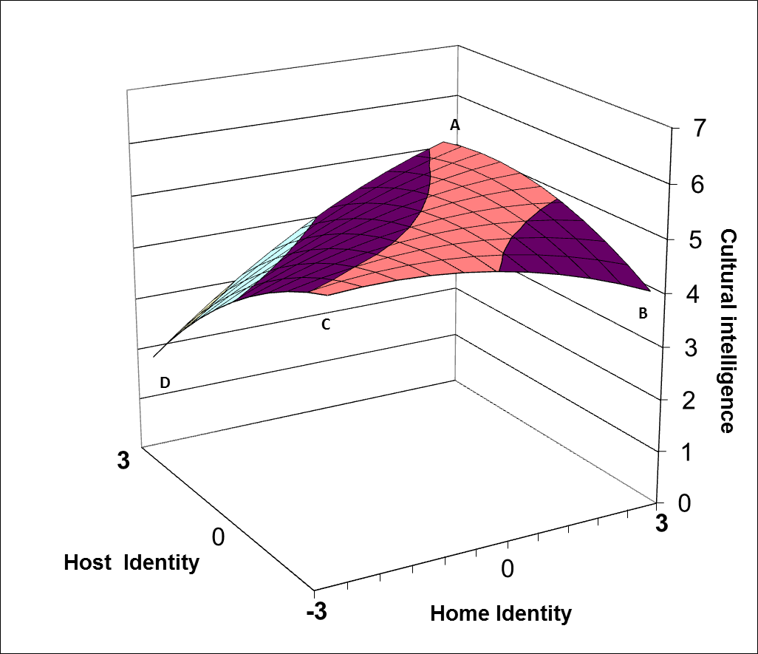
- Low Global Identity

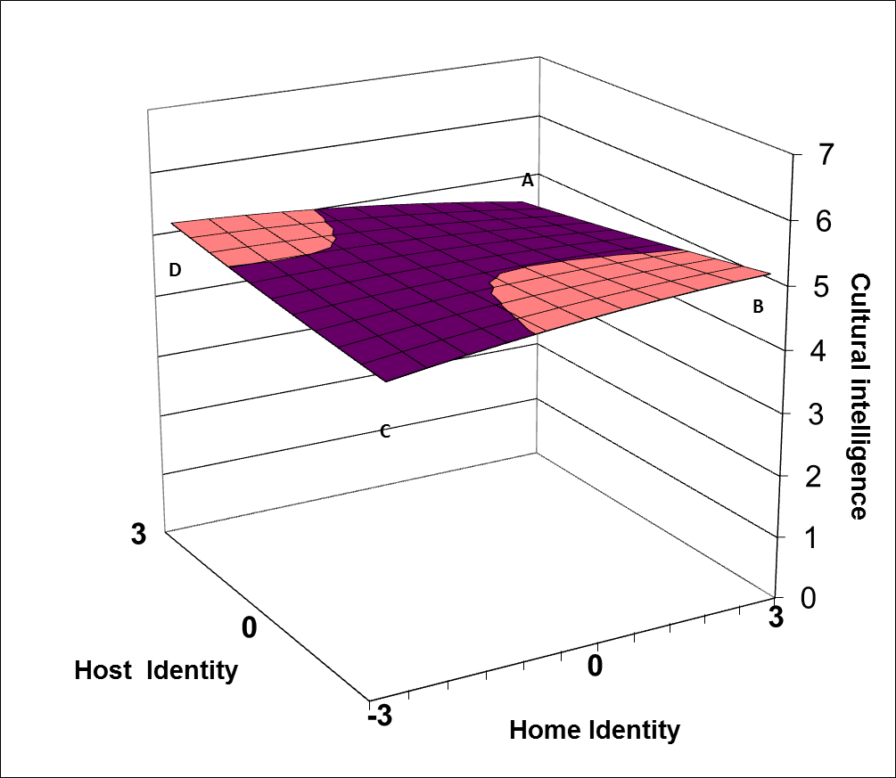
- High Global Identity

Note: A: high-home/high-host; B: high-home/low-host; C: low-home/low-host; D: low-home/high-host.
Figure 2.
Response Surfaces for Leadership Perception

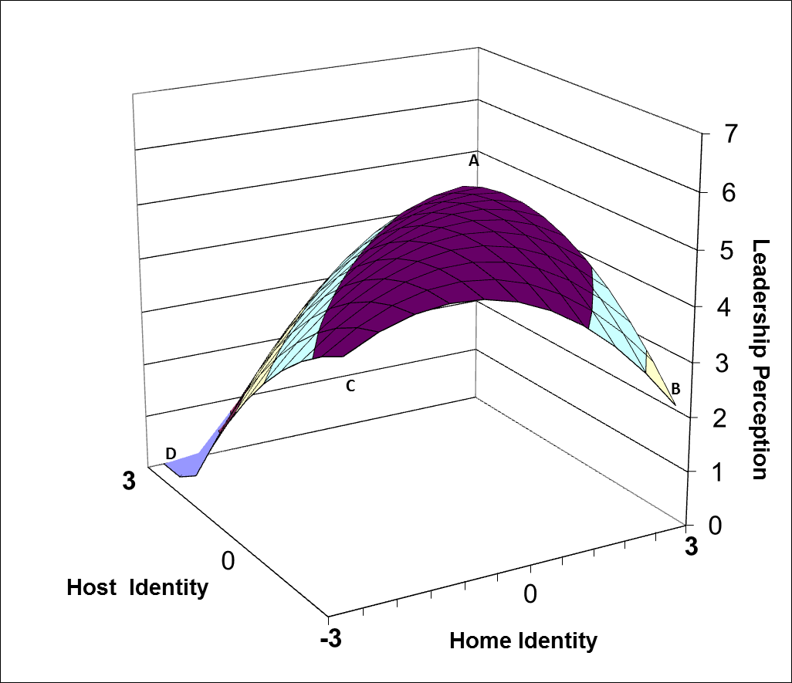
- Low Global Identity

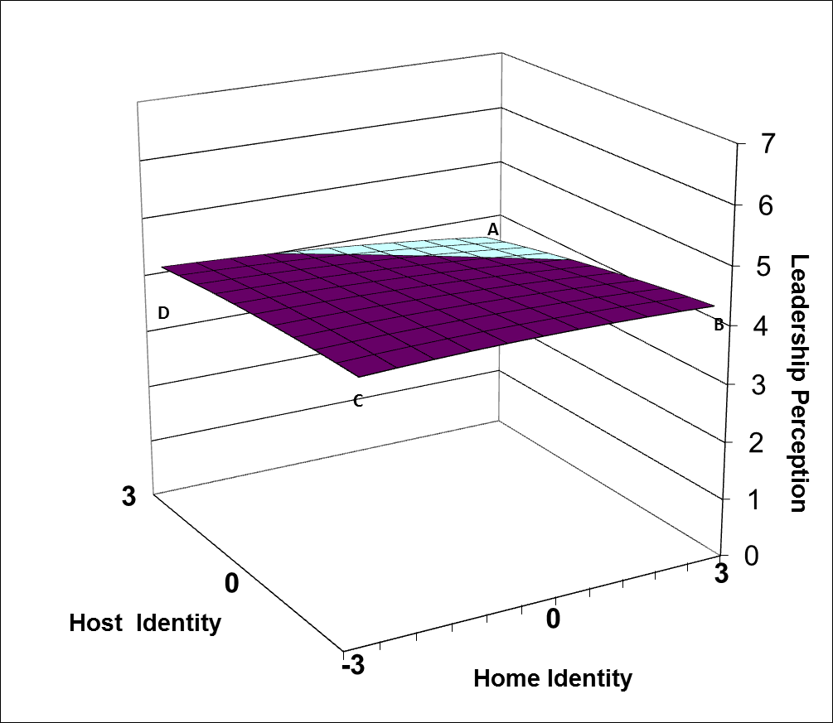
- High Global Identity

Note: A: high-home/high-host; B: high-home/low-host; C: low-home/low-host; D: low-home/high-host.

Erez et al. (2013) included both culture-specific identity and global identity in their study, but treated them as dependent variables.

